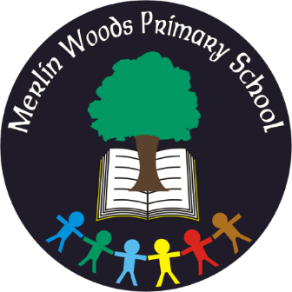
Merlin Woods Primary School
Doughiska Road
Galway H91 D7VH
Tel: (091)761676
Roll No. 20350P

Materials & Book List – First Class 2022 - 2023

Items to be Purchased by Parents
Please use a specialist school bookshop (ie Easons, www.easonschoolbooks.com, ABC Books, www.abcbooks.ie or www.schoolbooks.ie ) for books and stationery as Dunnes Stores, Tesco, etc. do not have all the specific items needed
Quantity | Materials
1 | Pencil Case, Eraser, Pencil Sharpener & 30cm Ruler
3 | Large glue sticks
1 | Packet of Twistables Crayons
3 | Faber Castel HB Pencils
6 | Whiteboard/dry-wipe markers
1 | Plastic File with button fastener – A3 Size
2 | Plastic Files with button fastener – A4 size
1 | Plastic File with button fastener – A5 size
Books:
- Handwriting Today – Book A, Helen Woods, Prim-Ed
- Cracking Maths 1st Class, Gill & Macmillan
- Bua na Cainte 1, Edco
- Explorers SESE 1st Class, Folens
- Spell Well 1, CJ Fallon
- Tables Book, CJ Fallon
Copies:
5 – Copy Book Blank, 40 pages
4 – Project Book 15A, 40 pages
4 – Junior Copy Book (wide-ruled, not extra wide)
1 – Junior sum copy, 2cm squares
2 – Handwriting Copy B2 (red & blue lines)

Please label books, folders & belongings clearly with your child’s name

Book Rental and Parent contribution
Book Rental  Items covered  - textbooks for English  - PM readers for English  - class novels  - books for Religious Education  - personal tin whistle  - 24-hour Pupil Accident Insurance | €45
Parent Contribution  This includes  - class resources  - equipment  - art & craft materials  - photocopying  - electricity and running costs of the school | €60
Total | €105

How to Pay -
The above fees may be paid with bank card via our online payment app (www.databizsolutions.ie, click Parent Sign In to pay/sign up) OR in cash/cheque (made out to Merlin Woods Primary School) to the school office in a sealed envelope clearly marked with your child’s name and class. Please pay fees before 30th September 2022. Please do not hesitate to ask for a Payment Plan if it will make costs easier to pay.

1st Class Uniform: Checked skirt with navy knee socks or navy formal trousers (girls), navy formal trousers (boys), plain white polo shirt and the school sweatshirt worn with dark, flat shoes. Navy tracksuit bottoms to be worn on PE days only. The school uniform shop will help with sizes and the correct uniform.

The school uniform/sweatshirt may be purchased from The Schoolwear Centre, Liosbán Industrial Estate, Tuam Road, Galway, (091)755515, www.theschoolwearcentre.ie or Anthony Ryan’s, 16-18 Shop Street, Galway, (091)567061, www.shopschooluniforms.ie. Please ensure children are dressed in full uniform every day.

School bags, lunch boxes, water bottles, sweatshirts/jumpers, jackets and coats should be clearly labelled with your child’s name. We recommend purchasing iron on labels from the uniform shop.
Thank you

