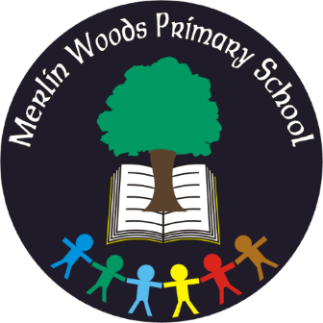
Merlin Woods Primary School
Doughiska Road
Galway H91 D7VH
Tel: (091)761676
Roll No. 20350P
Materials & Book List – Sixth Class 2022 - 2023
Items to be Purchased by Parents
Please use a specialist school bookshop (ie Easons, www.easonschoolbooks.com, ABC Books, www.abcbooks.ie or www.schoolbooks.ie ) for books and stationery as Dunnes Stores, Tesco, etc. do not have all the specific items needed
Quantity | Materials
1 | Pencil Case, Eraser, Pencil Sharpener & 30cm Ruler
4 | Blue or Black pens
3 | Red pens
1 | Maths Geometry Set, including compass/protractor - Important *
3 | Large glue sticks
1 | Packet crayons/Twistables/colouring pencils
3 | HB Pencils
5 | Drywipe/whiteboard markers
1 | Ring Binder Folder, dividers and Poly pocket sleeves
1 | A4 Tracing Paper Pad
2 | Plastic Files with button fastener – A4 size
1 | Basket (€2 in Mr Price/Euro Shop) Must fit books and copies
1 | Calculator
Books:
- Master Your Maths 6, CJ Fallon
- Fuaimeanna agus Focail 6, Folens
- Spell Well 6, CJ Fallon
- My Confirmation Year workbook - Veritas (If Your child is making their confirmation)
Copies:
3 – C3 88-page sum copies
1 – Handwriting Copy B4 (red & blue lines)
8 – 88-page Exercise Copies
3 – A4 Hardback Copies
Please label books, folders & belongings clearly with your child’s name
Book Rental and Parent contribution
Book Rental  Items covered  - Textbooks for English, Irish, Maths and SESE  - class novels  - readers for English  - books for Religious Education  - homework diary  - 24-hour Pupil Accident Insurance | €65
Parent Contribution  This includes  - class resources  - equipment  - art & craft materials  - photocopying  - electricity and running costs of the school | €60
Total | €125
How to Pay -
The above fees may be paid with bank card via our online payment app (www.databizsolutions.ie, click Parent Sign In to pay/sign up) OR in cash/cheque (made out to Merlin Woods Primary School) to the school office in a sealed envelope clearly marked with your child’s name and class. Please pay fees before 30th September 2022. Please do not hesitate to ask for a Payment Plan if it will make costs easier to pay.

6th Class Uniform: Checked skirt with navy knee socks or navy formal trousers (girls), navy formal trousers (boys), plain white polo shirt and the school sweatshirt worn with dark, flat shoes. Navy tracksuit bottoms to be worn on PE days only. The school uniform shop will help with sizes and the correct uniform.

The school uniform/sweatshirt may be purchased from The Schoolwear Centre, Liosbán Industrial Estate, Tuam Road, Galway, (091)755515, www.theschoolwearcentre.ie or Anthony Ryan’s, 16-18 Shop Street, Galway, (091)567061, www.shopschooluniforms.ie. Please ensure children are dressed in full uniform every day.

School bags, lunch boxes, water bottles, sweatshirts/jumpers, jackets and coats should be clearly labelled with your child’s name. We recommend purchasing iron on labels from the uniform shop.
Thank you

