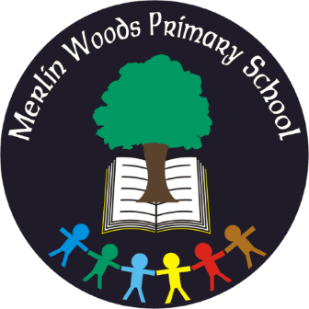
Merlin Woods Primary School
Doughiska Road
Galway H91 D7VH
Tel: (091)761676
Roll No. 20350P

Materials & Book List - Junior Infants 2022 - 2023

Items to be Purchased by Parents
Please use a specialist school bookshop (ie Easons, www.easonschoolbooks.com, ABC Books, www.abcbooks.ie or www.schoolbooks.ie ) for books and stationery as Dunnes Stores, Tesco, etc. do not have all the specific items needed
Quantity | Materials
1 | Pencil Case & Eraser (large)
3 | Large glue sticks
5 | Pencils (Faber Castell HB red, 3-sided pencil, Junior Grip)
1 | Packet of chubby crayons
3 | Whiteboard/dry-wipe markers
3 | Plastic Files with button fastener – A4 size
1 | Plastic File with button fastener – A5 size
2 | Packet of baby wipes
1 | Art apron
Junior Infants Text Books:
- Planet Maths (Junior Infants), Folens
- Pre-Reading Reading Zone Activity Book, Folens (white book with cow image)
- Sounds Good Phonics 1, Gill & Macmillan
Copies:
3 – Blank/plain day copy, 40 pages
1 – No. 15 project copy
1 – Junior sum copy, 2cm squares
Please label child’s books and folders clearly and ensure your child’s school bag will fit an A4 folder (for homework)
*Please also ensure your child has with them a spare pair of tracksuit bottoms, underwear and socks (in case of a toilet accident)

Please see overleaf for details regarding Book Rental
The school runs a compulsory Book Rental Scheme

The Book Rental for Junior Infants is €30. The cost incurred by the school for all the books is €76.30. The items covered by the Book Rental fee include English readers (children use on average 15 books per year at a cost of €3.50 each), nursery rhyme, handwriting and Religious Studies books.

We also request a Parent Contribution of €65 per child to be paid each year along with the Book Rental Fee outlined above. Total payment = €95. The €65 Parent Contribution goes towards class resources, equipment, art & craft materials, photocopying, electricity and running costs of the school, as well as 24-hour Pupil Personal Accident Insurance.

The above fees may be paid with bank card via our online payment app (www.databizsolutions.ie, click Parent Sign In to pay/sign up) OR in cash/cheque (made out to Merlin Woods Primary School) to the school office in a sealed envelope clearly marked with your child’s name and class. Please do not hesitate to ask for a Payment Plan if it will make costs easier to pay.

Uniform: Junior and Senior Infants wear plain navy tracksuit bottoms, a plain white polo shirt and the specialised school sweatshirt with crest.

The school uniform/sweatshirt may be purchased from The Schoolwear Centre, Liosbán Industrial Estate, Tuam Road, Galway, (091)755515, www.theschoolwearcentre.ie or Anthony Ryan’s, 16-18 Shop Street, Galway, (091)567061, www.shopschooluniforms.ie. The school wear shop can advise on sizing and correct uniform.
Please ensure children are dressed in full uniform every day.

School bags, art aprons, lunch boxes, water bottles, sweatshirts/jumpers, coats and jackets should be clearly labelled with your child’s name. We recommend purchasing iron on labels from the uniform shop.

Thank you

